Summer School – Junior 1 (P1-3)
Monday 15 – Friday 19 July: 9.30am – 12pm
Music Hall
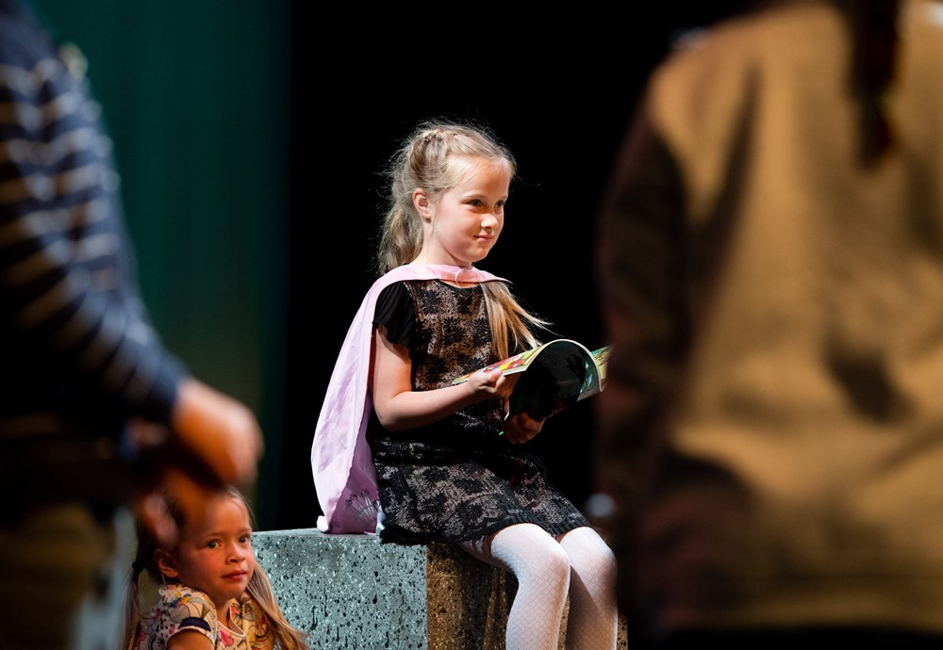
The participants will work towards a sharing of a brand new musical to be performed in the Big Sky Studio. This will include singing, actions and percussive elements.
For more information, please contact: creativelearning@aberdeenperformingarts.com
Booking open now – book online, phone or visit our box office: 01224 641122 £75

Summer School – Junior 2 (P4-7)
Monday 15 – Friday 19 July: 1pm – 4.30pm
Music Hall
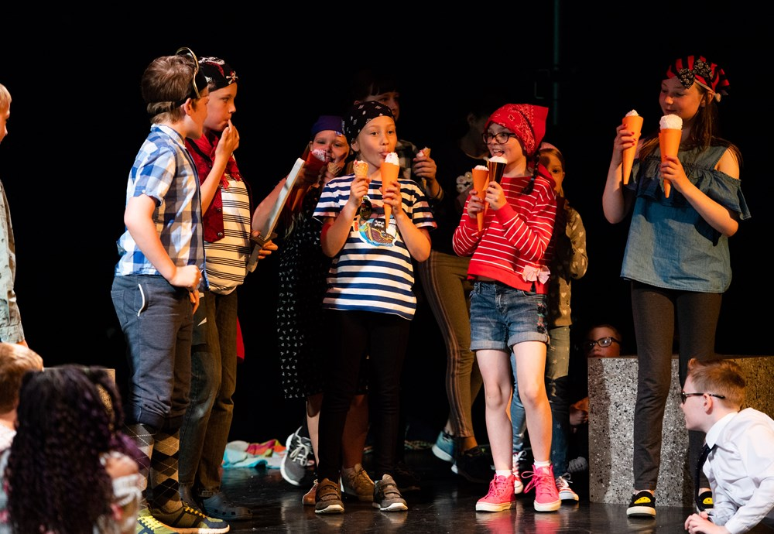

The participants will work towards a sharing of a brand new musical to be performed in the Big Sky Studio. This will include singing, actions and percussive elements.

For more information, please contact: creativelearning@aberdeenperformingarts.com
Booking open now – book online, phone or visit our box office: 01224 641122 £75

ZOG
Monday 15 – Wednesday 17 July
Mon 4.30pm, Tue – Wed 10.30am & 1.30pm
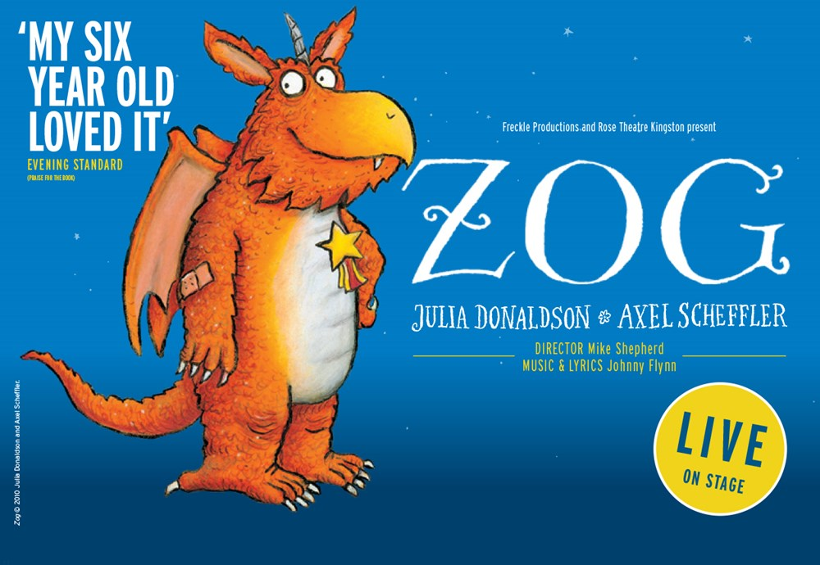
His Majesty’s Theatre
By Julia Donaldson and Axel Scheffler
Large in size, and keen in nature, Zog is so eager to win a golden star at Madam Dragon’s school, where dragons learn all the things that dragons need to know. Zog tries so very hard, perhaps too hard, and he bumps, burns and roars his way through years one, two and three.
Julia Donaldson and Axel Scheffler’s much‐loved Zog comes to life in Mike Shepherd’s (founder and Artistic Director of Kneehigh) magical adaptation with Johnny Flynn’s (award- winning actor and singer‐songwriter with The Sussex Wit) sumptuous folk score featuring live musicians. Katie Sykes’ design lifts the book from the page and creates a real and fantastical world. From the team behind Tiddler and Other Terrific Tales and Tabby McTat,
Zog promises to be roaring fun for all ages.
Children £2 off | Groups 10+ £2 off |
Box office booking line: 01224 641122

Cinderella (Panto 2019-20)
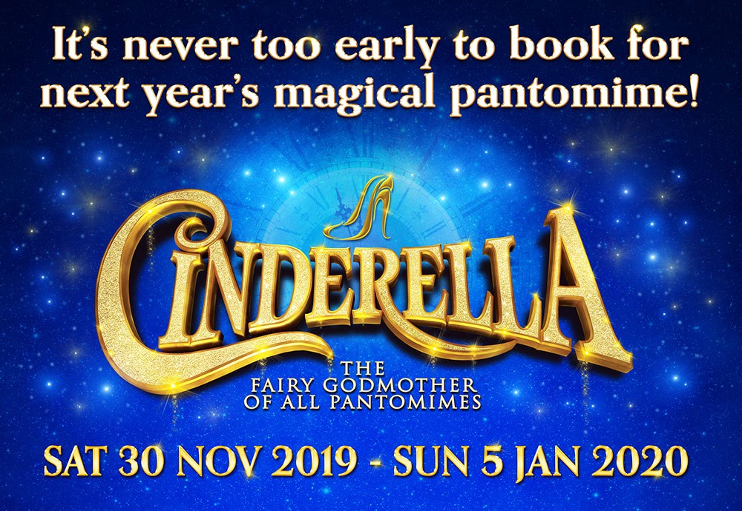
Saturday 30 November – Sunday 5 January 2020
His Majesty’s Theatre

This festive season take your school on an enchanted journey to His Majesty’s Theatre for this year’s must-see production of Cinderella, the Fairy Godmother of all pantomimes!
Your school shall go to the ball with yet another spectacular panto, packed with all of the traditional pantomime ingredients you have come to expect from Aberdeen’s biggest festive production.
With laugh-out-loud comedy, jaw-dropping special effects, stunning song and dance and plenty of boos and hisses as the ultimate pantomime is brought magically to life.
The clock is already ticking…book soon to guarantee an unforgettable experience for children (and teachers!)
SCHOOLS: £12.50 per ticket plus 1 teacher free for every 10 pupils.
Box office booking line: 01224 641122

Oor Wullie
Tuesday 3 – Saturday 7 March 2020
Tue – Sat 7.30pm, Thu 2pm, Sat 2.30pm
His Majesty’s Theatre
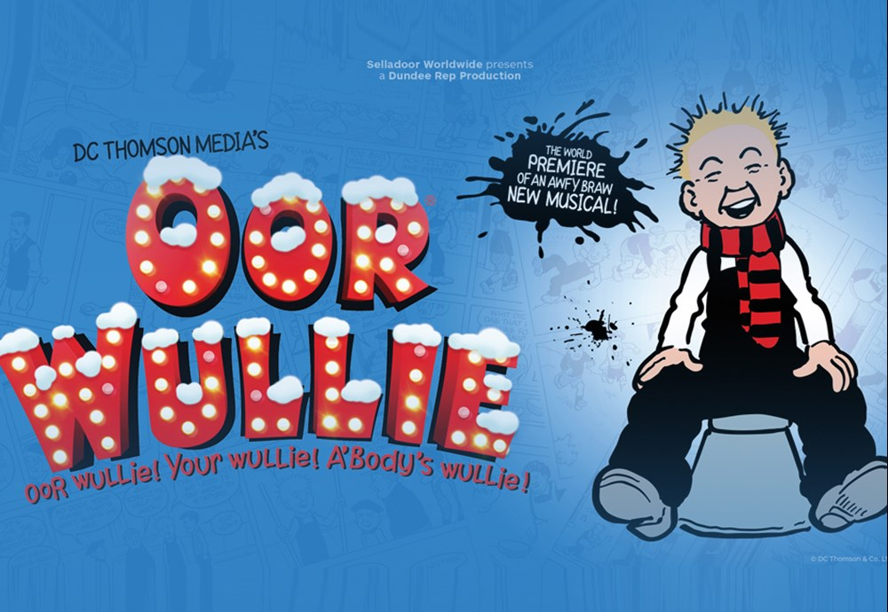

Dundee Rep Ensemble and Selladoor Productions in association with Noisemaker present Oor Wullie
Jings, Crivvens, Help Ma Boab! Scotland’s cheekiest, spiky-haired scamp is back! Only question is; where’s his bucket?!
Join Wullie, Fat Boab, Soapy Soutar, Wee Eck, and the rest of the Sunday Post gang, in a brand new musical adventure celebrating their 80th anniversary as Scotland’s most beloved comic strip. Proving that even at 80-years old he’s still Oor Wullie! Your Wullie! A’body’s Wullie!

Schools offer - Wed 7.30pm & Thu 2.00pm - £11.00 plus 1 free teacher for every ten pupils purchased.
Box office booking line: 01224 641122

