Due to current restrictions parents will not be permitted to enter the school playground. Parents will not be permitted to use the school carpark unless they have a valid blue badge, and in this case they should park only in a disabled bay. School gates will open at 8.50am, so pupils should arrive no earlier than this.
Class information | Arial View
Nursery Pupils  For AM and PM sessions parents/carers and child should wait in a socially-distanced line outside of the nursery gate until a staff member comes to collect pupils.  Parents/carers must wait at this gate for their child at the end of the session.  Please ensure that arrival at the gate is at the correct staggered time. | 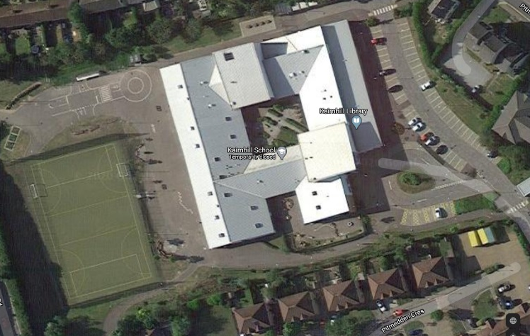
P1EB – Miss Booth

In the morning parents/carers and child should wait in a line outside of the playground at this gate until the teacher comes to collect pupils.
Parents/carers must wait at this gate for their child at the end of the session/day.

P1EB pupils will enter and exit the school via their classroom door which is marked.
P1FH – Mrs Forrest & Mrs Hunter

In the morning parents/carers and child should wait in a line outside of the playground at this gate until the teacher comes to collect pupils.
Parents/carers must wait at this gate for their child at the end of the session/day.

P1FH pupils will enter and exit the school via their classroom door which is marked.
P2SM – Miss Morrison

In the morning parents/carers and child should wait in a line outside of the playground at this gate until the teacher comes to collect pupils.
Parents/carers must wait at this gate for their child at the end of the session/day.

P2SM pupils will enter and exit the school via their classroom door which is marked.
P2/3 – Mrs Pirie

In the morning parents/carers and child should wait in a line outside of the playground at this gate until the teacher comes to collect pupils.
Parents/carers must wait at this gate for their child at the end of the session/day.

P2SM pupils will enter and exit the school via their classroom door which is marked.
P3 – Mrs McLean

P3 pupils may enter and leave the playground via any of the 3 gates. If parents are collecting their child, please ensure your child knows which gate you will collect them from.

P3 pupils will enter and exit the school via their classroom door which is marked. When entering the playground in the morning, pupils should go directly to the line at their door.

P3/4 – Miss Jamieson

P3/4 pupils may enter and leave the playground via any of the 3 gates. If parents are collecting their child, please ensure your child knows which gate you will collect them from.

P3/4 pupils will enter and exit the school via the main infant door which is marked. When entering the playground in the morning, pupils should go directly to the line at their door.

P4 – Miss Fraser

P4 pupils may enter and leave the playground via any of the 3 gates. If parents are collecting their child, please ensure your child knows which gate you will collect them from.

P4 pupils will enter and exit the school via their classroom door which is marked. When entering the playground in the morning, pupils should go directly to the line at their door.

P4/5 – Mr Skinley

P4/5 pupils may enter and leave the playground via any of the 3 gates. If parents are collecting their child, please ensure your child knows which gate you will collect them from.

P4/5 pupils will enter and exit the school via the main infant door which is marked. When entering the playground in the morning, pupils should go directly to the line at their door.

P5 – Mr Middleton

P5 pupils may enter and leave the playground via any of the 3 gates. If parents are collecting their child, please ensure your child knows which gate you will collect them from.

P5 pupils will enter and exit the school via the main senior door which is marked. When entering the playground in the morning, pupils should go directly to the line at their door.

P6 – Mrs Qureshi

P6 pupils may enter and leave the playground via any of the 3 gates. If parents are collecting their child, please ensure your child knows which gate you will collect them from.

P6 pupils will enter and exit the school via the main senior door which is marked. When entering the playground in the morning, pupils should go directly to the line at their door.

P6/7 – Miss Serna

P6/7 pupils may enter and leave the playground via any of the 3 gates. If parents are collecting their child, please ensure your child knows which gate you will collect them from.

P6/7 pupils will enter and exit the school via their classroom door which is marked. When entering the playground in the morning, pupils should go directly to the line at their door.

P7 – Mrs Westacott

P7 pupils may enter and leave the playground via any of the 3 gates. If parents are collecting their child, please ensure your child knows which gate you will collect them from.

P7 pupils will enter and exit the school via their classroom door which is marked. When entering the playground in the morning, pupils should go directly to the line at their door.

